Submitted by
Feyisayo Famakinde

Abstract
Intrusion detection systems are guardrails for a network; they detect issues within systems and report them as alerts. Security Information Event Management(SIEM) systems often come with these agents, one of the many SIEM’s available is called Wazuh. This document would provide information on the installation and configuration of its agents and console.
Executive Summary
Register an IDS agent with a Security Information Event Management (SIEM) Console

Registering an Intrusion detection Agent with a Security Information Event Management Solution.
  - EXECUTIVE SUMMARY

Overview - The Quick Pitch
This summary will demonstrate how Wazuh agents collect information about every activity within a particular operating system after deployment and configuration. The information collected would also be displayed in a Graphical User Interface where data can be analyzed and alerts verified.

The Solution

Installation.
For this solution, I will be working with three Virtual Machines in VirtualBox: two Windows Server VM and Ubuntu Server VM. For the Wazuh Dashboard, I installed an OVA file; an already packaged image that has all the necessary packages to run the Wazuh Solution in Virtual box on both windows machines.
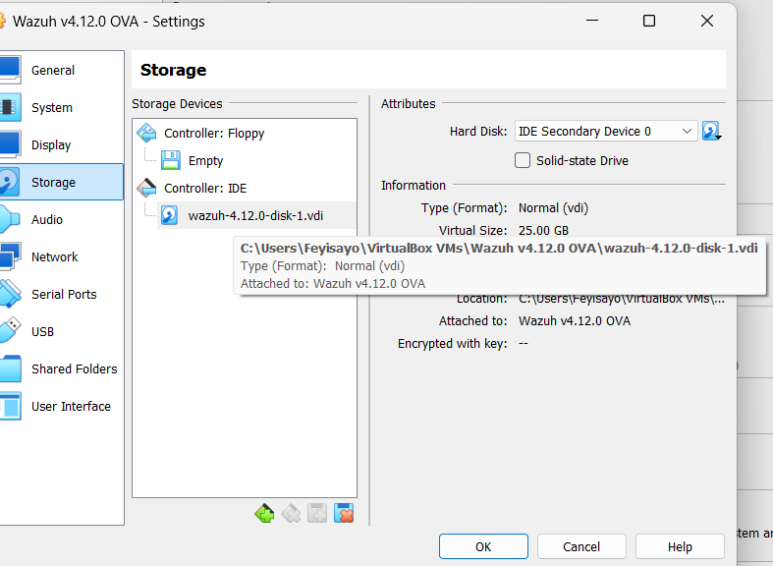
Image above showing information on the Wazuh OVA image in virtual box.

Also, to ensure all my Virtual Machines can communicate with each other and the internet, I attached both a NAT adapter and Host Only adapter. The NAT adapter makes connections to the internet possible while the Host Only adapter makes connections within the VMs possible. Starting up the Wazuh server, authenticating with the default username and password then I tried to access the dashboard from my Windows Server since it was the only machine with a GUI on my list. I had a bit of challenge accessing it from my browser because I inputted “http” instead of “https” I got an error because the dashboard/server listens on port 443. I was able to find that out after accessing the dashboard config file, I was able to retrieve the appropriate IP address by using the “ip a” command within the Wazuh server. VirtualBox host network is within the 192.168.56.0/24 network, so I knew to look for IP addresses within that range.
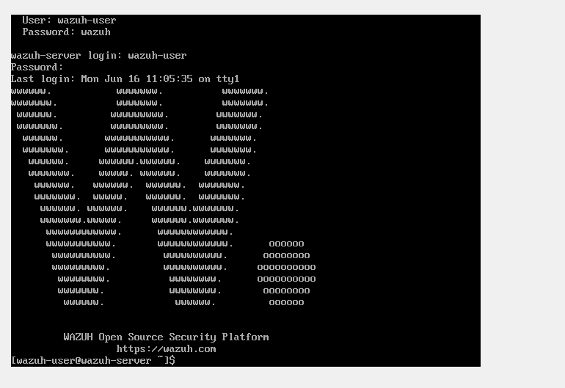
Image above shows the welcome screen of the Wazuh server.

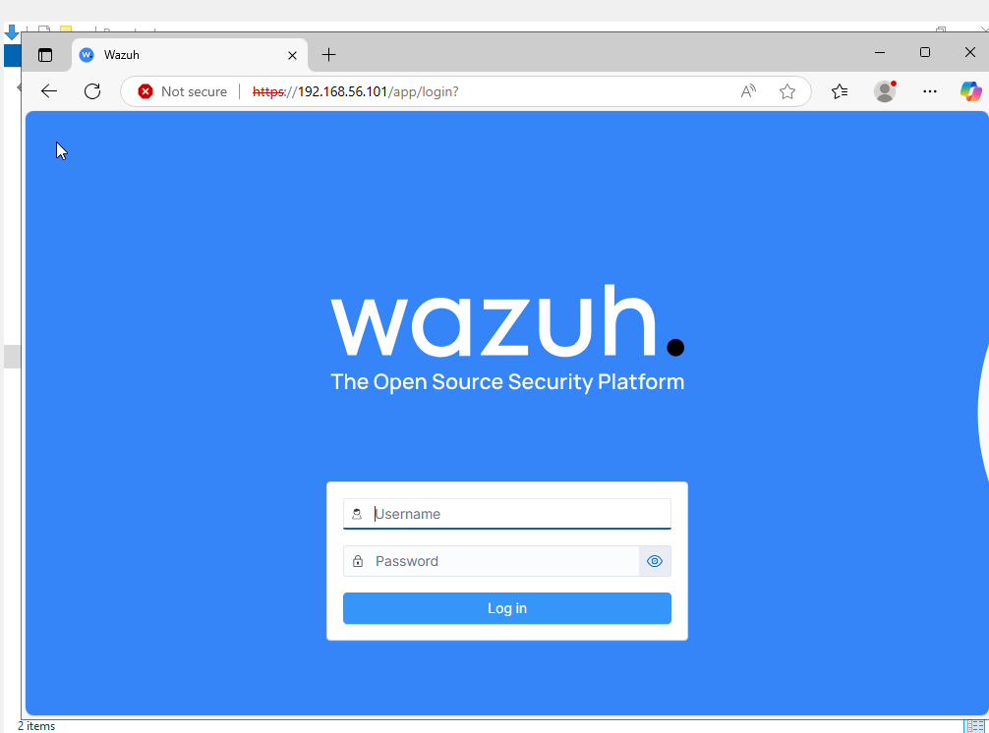
Image above shows the landing page of the Wazuh dashboard. You are granted access using admin as password and username.
After authenticating into the dashboard, it was time to deploy agents to my Windows and Ubuntu servers. Selecting the appropriate OS, including the server’s IP address then copying the commands provided in the deploy agent interface. Running commands in the appropriate machines installs the wazuh agents on each machine, for configuration I ran into some issues with the agents not recognizing the wazuh manager IP.

For Windows, after installation a prompt comes up with a box for the manager IP, inputting Wazuh’s server IP address for the Virtual Box host only Network Interface is the correct value here.

For Ubuntu, although the command for installation has the variable configured for some reason probably due to shell complexities, the value is not configured. I had to do this manually at /var/ossec/etc/ossec.conf which is the configuration file for the agent.
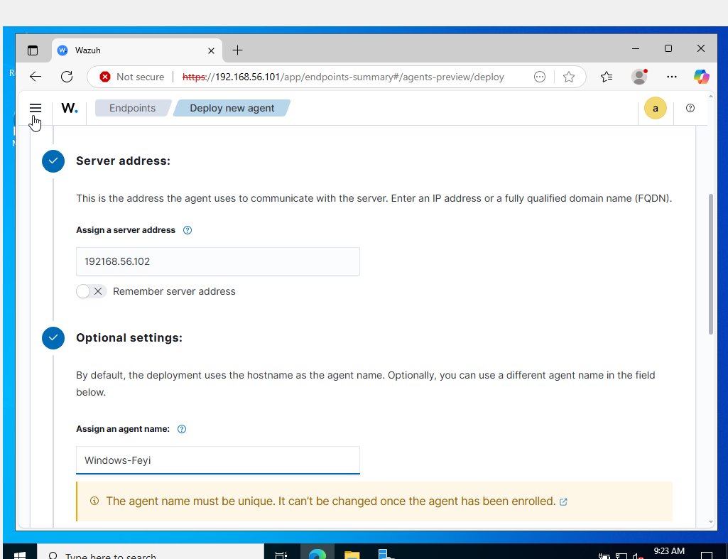
Image showing Interface for the deployment of a new agent with the IP address of the target server and the assigned agent name.

Configuration.
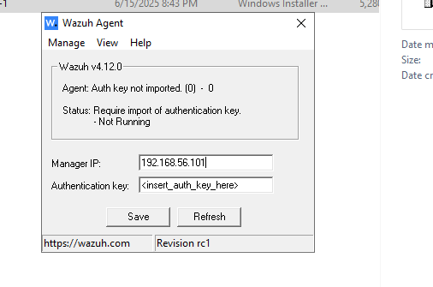
Image above shows configuration for the Manager IP on Windows.

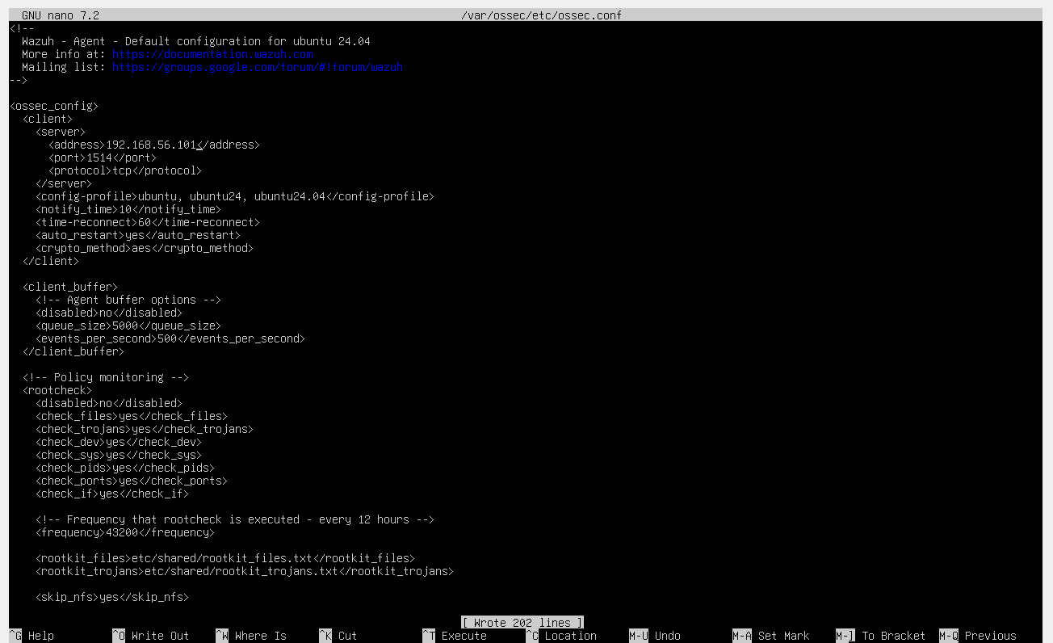
Image above shows configuration for the Manager IP on Ubuntu

Once everything is configured properly and the services are restarted, the agents should show up as active on the dashboard. I was able to access the agents by clicking on the agents’ button, scrolling down then selecting any of the agents I need information on.

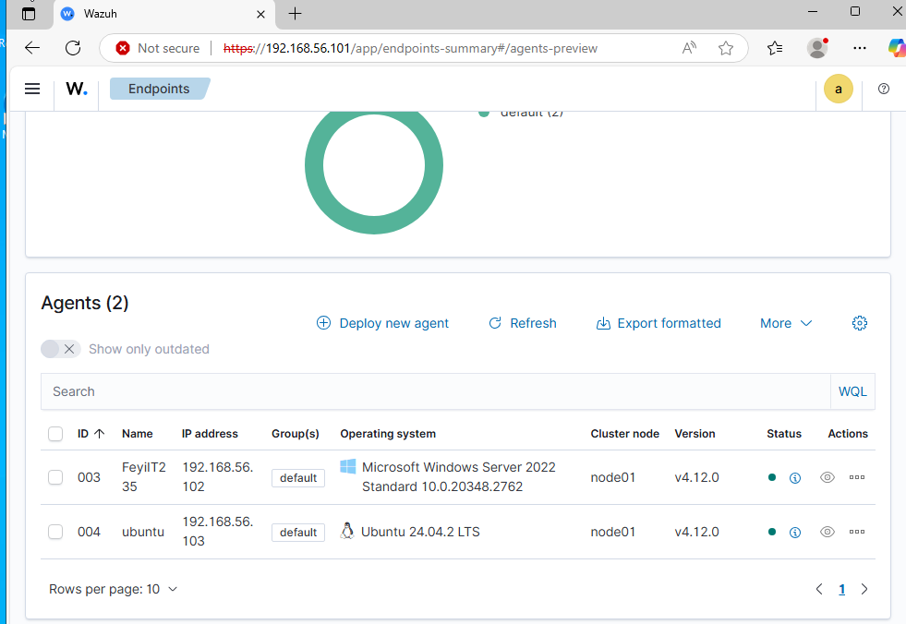

Image above shows the agents deployed on each of my VMs, the green button under the status bar shows they are active.

Clicking on any of these agents takes you to a dashboard with widgets that contain event counts, evaluation based on the MITRE attack framework and a Vulnerability detection widget. Clicking on any of the widgets takes you to a larger dashboard with more details.
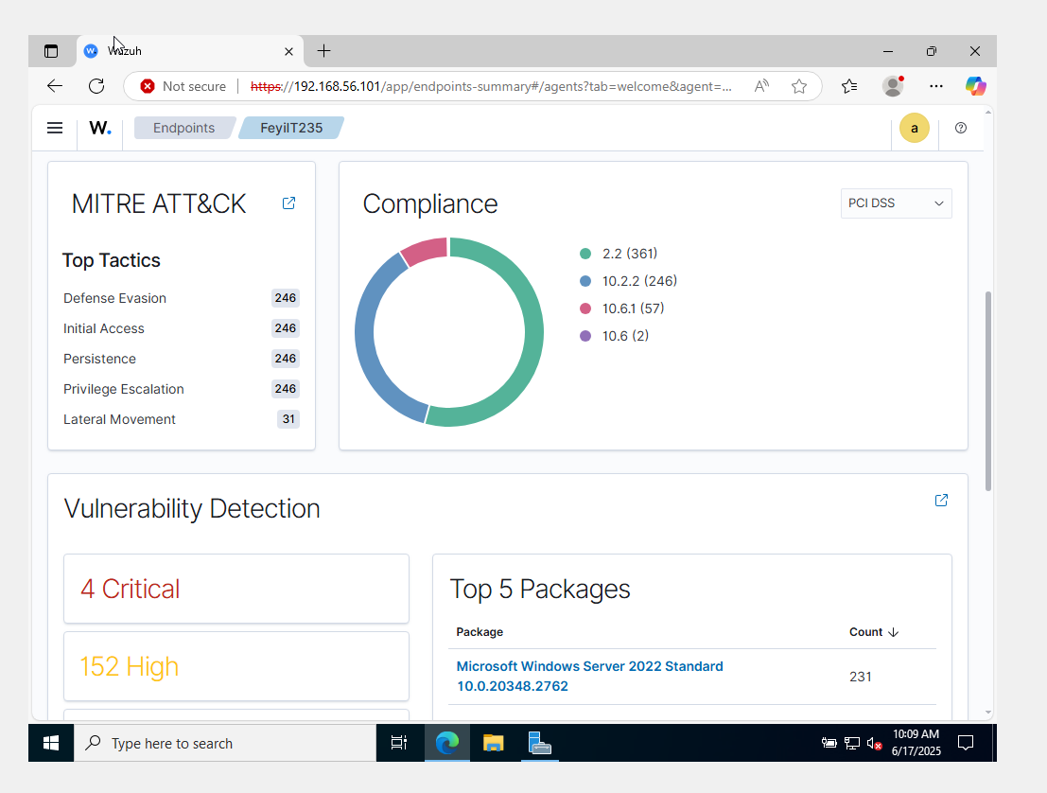
Image above shows my Windows Server dashboard.

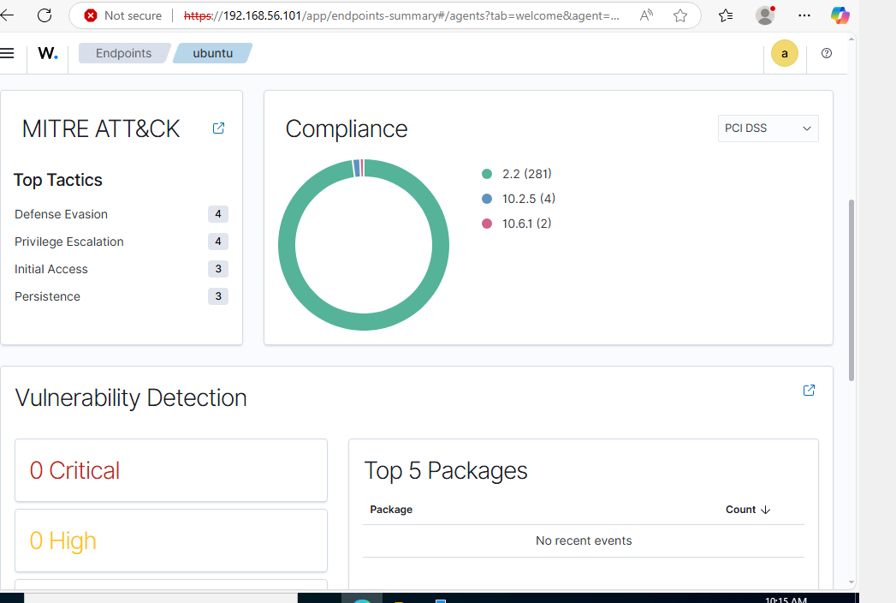
Image above shows my Ubuntu Server dashboard.

Network Issues.

I didn’t encounter lots of networking issues but one major error I encountered was starting up the Wazuh agent after booting it back up. There were times when I needed to access the dashboard, but I got a blank screen, the API wasn’t available at times but after doing my research I was able to resolve these issues.
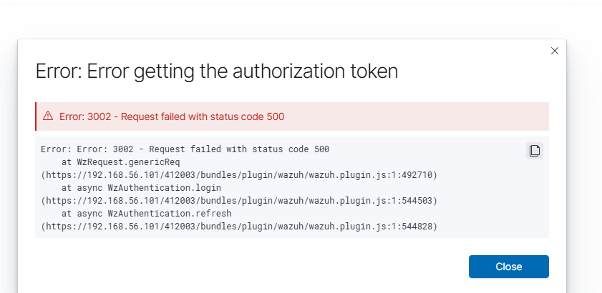
Image above shows the wazuh API failing
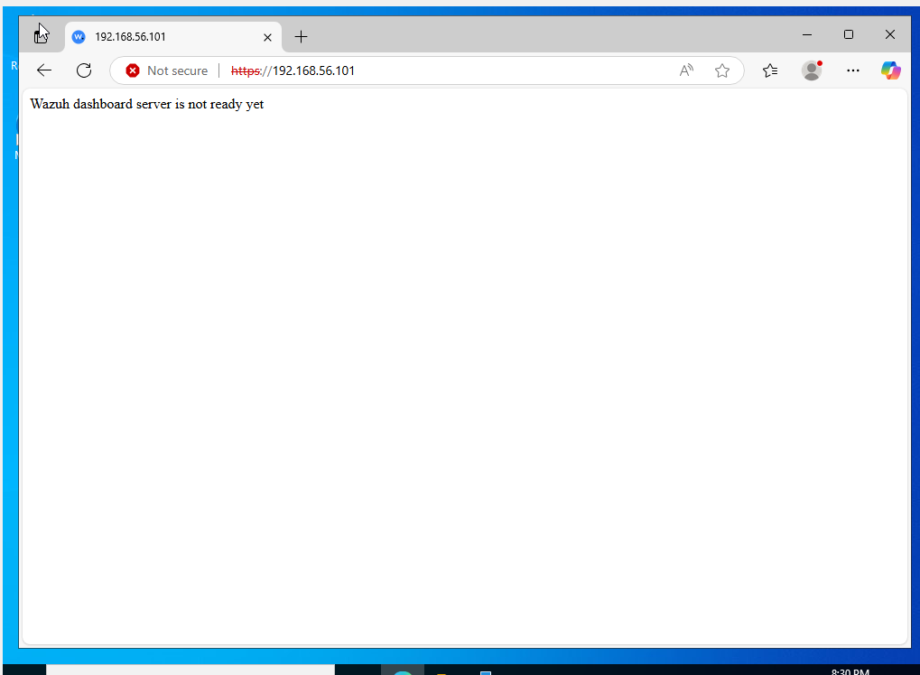
Image above shows the Wazuh dashboard unreachable.

To troubleshoot, I had to look at the logs first, the command “tail -n 50 /var/ossec/logs/api.log” shows the reason the API might be failing. From there I discovered that the wazuh-db service was not running. After some research online, I was able to resolve the issue by restarting the wazuh-indexer which contains all the services needed by the wazuh manager. The command used was “sudo /var/ossec/bin/wazuh-control restart” this reloads all the packages and daemons responsible for the successful initialization of the wazuh API and dashboard. Then check the status with “sudo /var/ossec/bin/wazuh-control status” to confirm availability.
For the dashboard, I checked the status with “sudo service wazuh-dashboard status” confirmed it was in a failed state then restarted with “sudo service wazuh-dashboard restart”.

Report Summary.

- Date Range: June 17 – June 18, 2025
- System Monitored: Ubuntu 24:04, Windows Server 2022
- IDS Tool: Wazuh
During the monitoring period from June 17 to June 18, Wazuh detected 40 authentication failures on the Ubuntu server and 184 authentication failures on the Window Server. Brute-force attacks through SSHd and an unknown user.
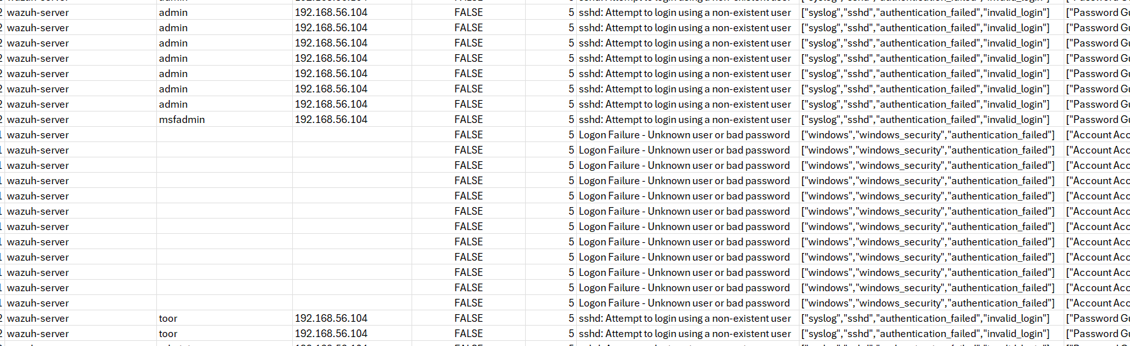
An Image showing the failed logon on both servers.
Here is a link to the report on the events
Wazuh Events (Please press CTRL + click to access link)

Identified Baseline Deficiencies
- Insecure Credential Posture: The initial deployment relied on default system-level credentials (wazuh-user / wazuh) and unrotated web console credentials (admin / admin).
- Dashboard Availability Vulnerabilities: Running the presentation tier directly on the resource-constrained all-in-one appliance led to API handshake failures (HTTP 500 / Error 3002) and "Wazuh dashboard server is not ready yet" service crashes caused by underlying wazuh-db process drops.
- Unstructured Upgrade Workflows: Agent enrollment relied on manual agent-side IP input, with no automated lifecycle management, rolling update plans, or version-pinning strategies.
- Privacy Ingestion Gaps: Raw auth failure logs ingested unmasked string tokens, exposing passwords in username fields to all dashboard operators.
- Accessibility Limitations: Operational dashboards relied entirely on monochromatic red/green status markers, offering no semantic structure or screen-reader accommodations for security analysts
Technical Enhancements & Reliability Engineering
- Credential Hardening & Identity Management: Because Wazuh shares internal state tokens across the manager API, OpenSearch indexer and dashboard layers, credentials must be rotated across the operating system.
- Multi-Instance High-Availability (HA) Dashboard Design: The Wazuh Dashboard is an asynchronous, stateless interface querying the Wazuh Indexer on port 9200 and the Wazuh Manager API on port 55000. Running multiple redundant instances behind a load balancer removes single points of failure.
- Coordinated Update & Upgrade Lifecycle: To protect against system failure errors, the upgrade of the indexer, agent and dashboard needs to be orchestrated in phases. Upgrades are done remotes through the built-in upgrade manager via the manager’s console
- Data privacy and protection: Custom log decoders are deployed on the ingestion layer to sanitize authentication strings prior to indexing. Log data was configured to be purged after 90 days.
- Multi-Modal Visual Signifiers: The default Wazuh UI communicates status almost exclusively through color-coded rings and dots (e.g., green for active, red for critical vulnerabilities). The refined configuration included texts such as ACTIVE, WARN, OFFLINE with color-codes for user accessibility.

Conclusion.

From the summary above, Wazuh provides stellar detection solutions when properly configured. We can conclude by acknowledging that Intrusion Detection Systems are vital to the health of a network because they provide information on events that happen within the network. With this information, security teams are aware of potential attacks on the organization’s assets and what to do to ensure solid protection of the network.

Also, refining a SIEM implementation requires moving beyond simple connectivity and agent enrollment. By pairing high-availability architecture and structured update lifecycles with robust credential hygiene, log sanitization and accessible dashboard design. The Wazuh deployment evolves from a vulnerable single-node lab into a resilient and enterprise-ready monitoring platform that balances robust security with ethical responsibility.

Refinement Section

This report records the changes I have made in my SIEM for intrusion detection installation project and the challenges they addressed including ethical considerations.

Improvements and Challenges.

Hardening & Identity Management
- Challenge: The Wazuh components(agents and dashboard manager) use default credentials so there is risk of exposure in case of an attack.
- Refinement: I replaced default passwords with secure passwords and saved them in a keystore.

High Availability Dashboard Architecture
- Challenge: In the original design, if the single OVA node halted or experienced indexer restart delays, analyst visibility was completely lost
- Refinement: Added a second dashboard node and HAProxy load balancing with SSL termination and session persistence. Both dashboards connect to clustered Indexer and Manager nodes.

Coordinated Update Lifecycle
- Challenge: Updating agents before the manager can cause compatibility and telemetry issues.
- Refinement: Adopted a Manager-First, Agent-Second process, automated configuration backups and used agent_upgrade for rolling endpoint updates.

Integration of Ethical Considerations

Emphasis was placed on data sanitization to improve accessibility while also improving data privacy.
- Logs sanitization: Added masking rules to prevent accidentally entered passwords from being stored in SIEM logs.
- Proportional Monitoring: Limited monitoring to security events, system anomalies, and service logs while excluding personal user data.
- Data Retention: Applied lifecycle policies to archive and delete telemetry after required audit periods.
While examining the project I was able to pinpoint the limitations by placing myself in the place of the user and the organization the SIEM protects. I was able to determine the improvements by approaching them from reliability, security and operational markers.
I believe these refinements would tighten the security surrounding data storage, user accessibility and infrastructure reliability.

